Materials Management (MM)

Master Data
Search Term Vendor (Mid-West Supply) | 013
Material (Chain Lock) | CHLK1013

Organizational Units
Company Code (Global Bike Inc.) | US00
Plant (Miami) | MI00
Plant (San Diego) | SD00
Storage Location (Trading Goods) | TG00
Sales Organization (US East) | UE00
Distribution Channel (Wholesale) | WH

Employees involved
Joyce Hausman | Contract Manager
Sandeep Das | Warehouse Supervisor
Sergey Petrov | Warehouse Employee
Wilton Saban | Inventory Supervisor
Alberto Conti | Inventory Assistant
Tirrell Winsten | Purchasing Agent 1
Aura Maxwell | Purchasing Agent 2
Tatiana Karsova | Goods Receipt Clerk
Silvia Cassano | AP Accountant
Shuyuan Chen | Heads of Accounting

As requested in the instructions, replace the instructor’s screenshots with your own and answer any questions posed in each step.

Step 5: Create Purchase Requisition
Explain the meaning of the Purchasing Group, Purchasing Organization, Company Code and Plant. (Look back at the GBI structure information.) Purchasing Group represents a buyer or group of buyers responsible for purchasing activities. A Purchasing Organization is the unit responsible for procurement of materials and services for one or more plants or company codes. A Company Code is the smallest organizational unit for which a complete, self-contained set of accounts can be drawn up. A Plant is an operating unit within a company where goods are produced, stored, or from which services are provided.

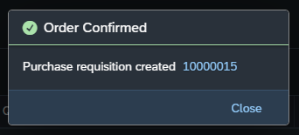

Step 6: Manage Stock
Why has the purchase requisition creation not changed the stock values?
A Purchase Requisition is a request or internal document that indicates the need for a material or service. It is not an actual procurement or inventory transaction.

Step 7: Create RFQ
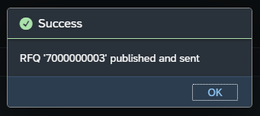

Step 8: Create Quotation from Vendor
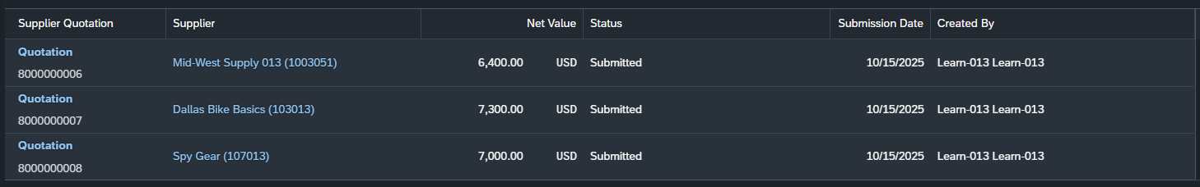
Explain from a business point of view what you did in this step.
Formal document used by a company to ask vendors or suppliers to provide a price quote and terms for specific goods or services.
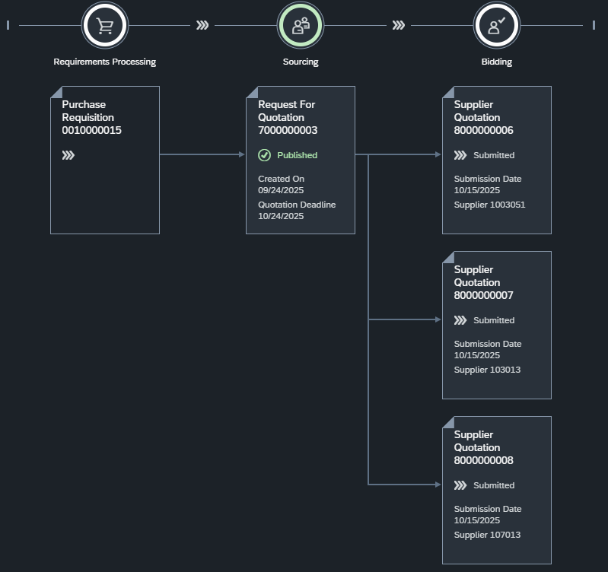

Step 10: Create Purchase Order Referencing an RFQ
Explain why you created two items in your purchase order.
To trigger another purchase order
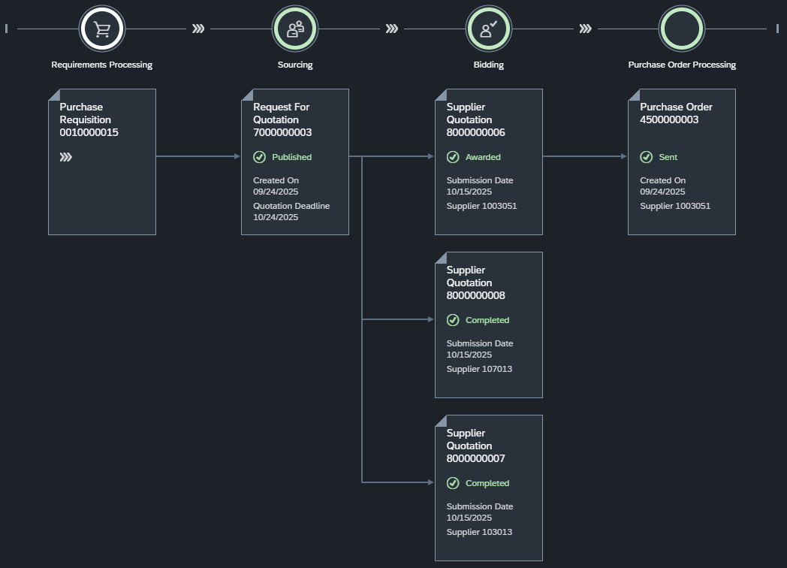

Step 11: Display Purchase Order

Step 12: Post Goods Receipt for Purchase Order

What is the stock type of the goods you received?
Quality Inspection

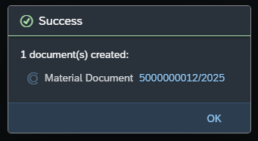

Step 13: Check Received Goods
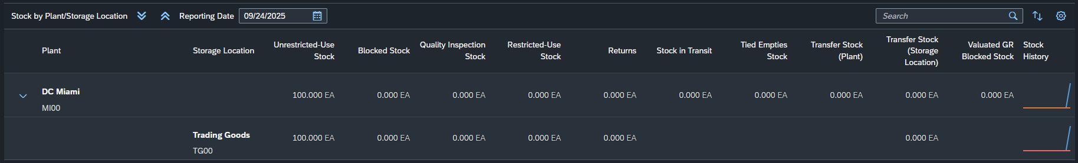
*I forgot to take a screenshot before transferring the material*
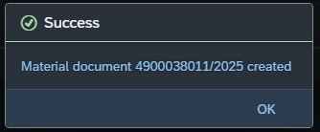
In practice, what would need to happen before the material was transferred from Quality Inspection to Unrestricted-Use?
Check whether the correct goods and quantity were delivered before posting them to unrestricted-use stock.

Step 14: Check Physical Goods Receipt
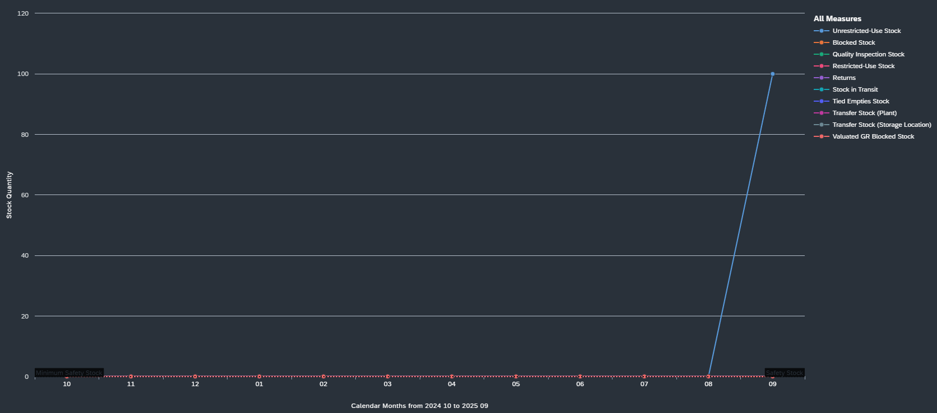

Step 15: Create and Post the First Supplier Invoice

Explain how the reference relates to the supplier invoice received by accounting. How does this invoice relate to the purchase order items?
It helps match supplier invoice and purchase order ensuring that material, quantity, and price billed by the supplier match with what was ordered.
Why does the choice for Tax Jurisdiction make sense?
Because every state has different percent of tax
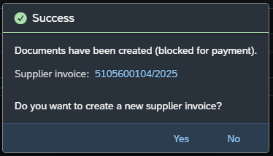

Step 16: Display Purchase Order History
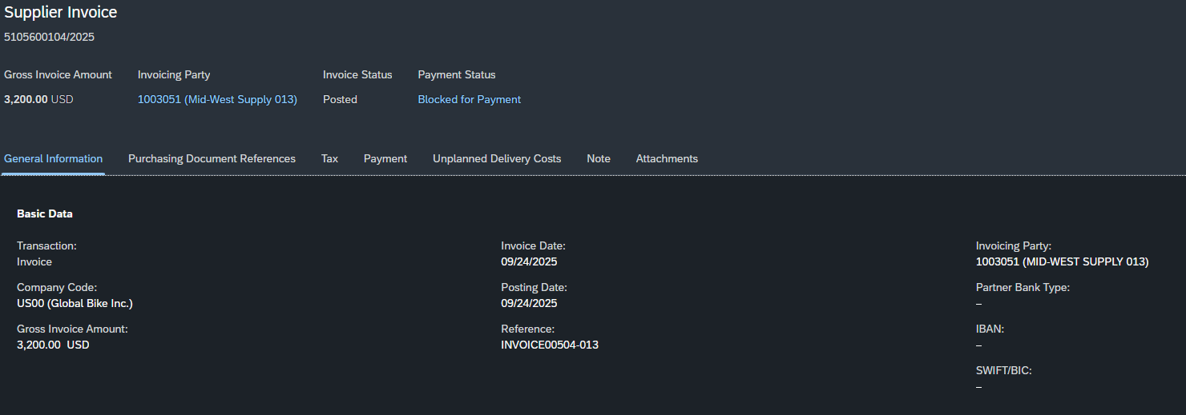

Step 17: Display Document Flow
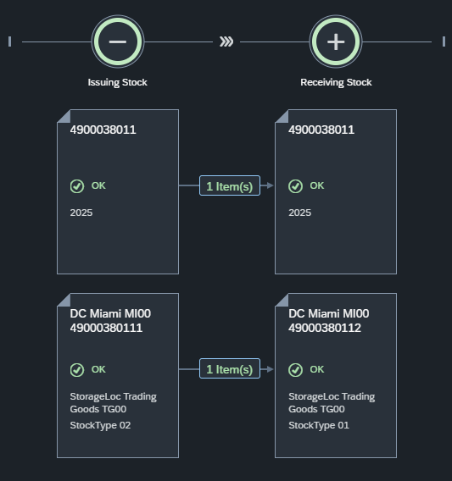

Step 18: Post Goods Receipt for Purchase Order
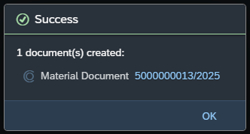

Step 19: Check Physical Goods Receipt
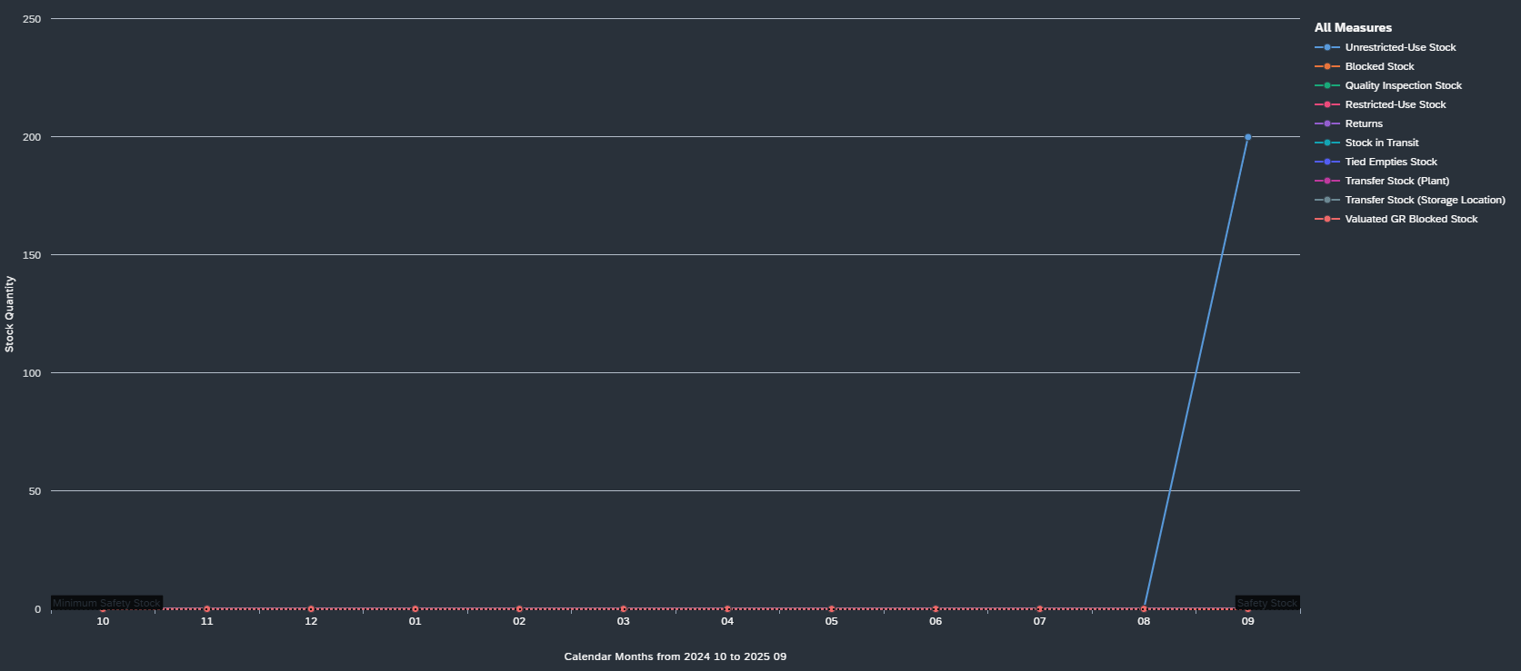

Step 20: Create and Post the Second Supplier Invoice
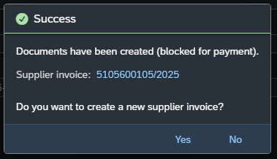

Step 21: Post Outgoing Payment
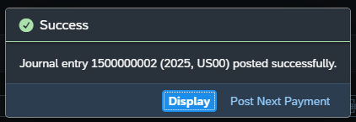

Step 22: Display Vendor Balance
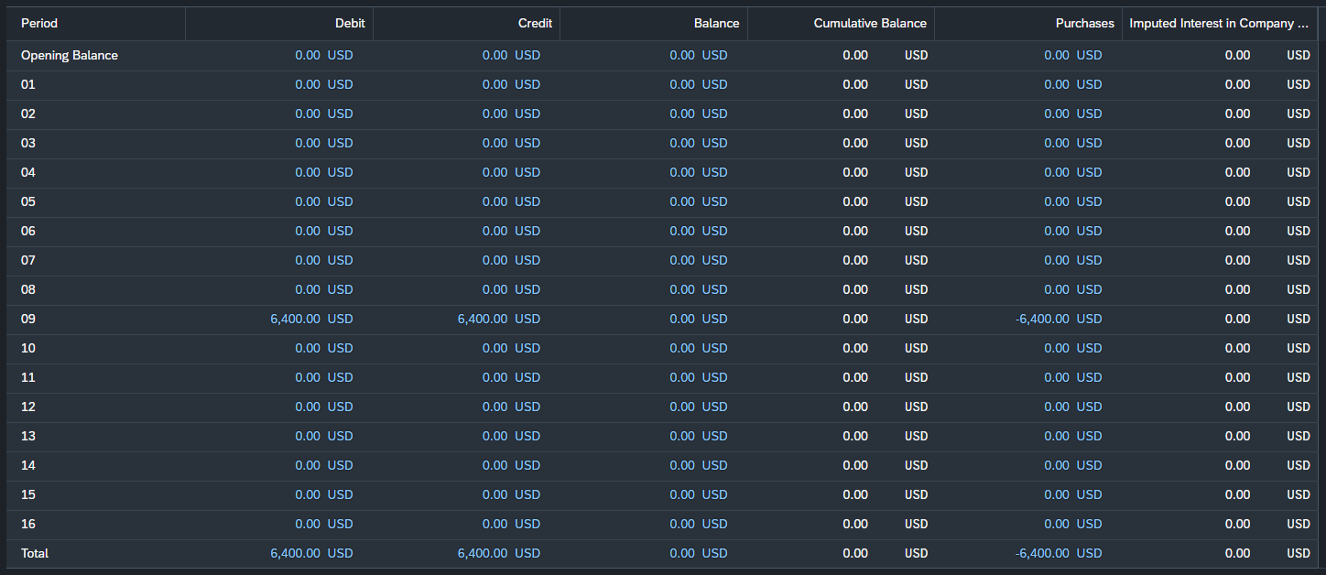

Step 23: Display Purchase Order History
